# Chandeliers

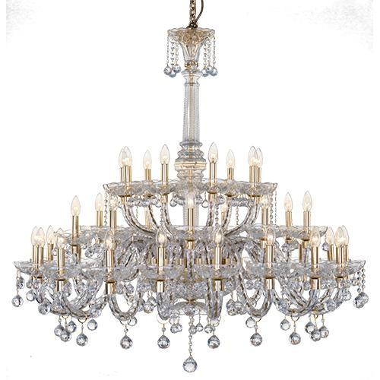

**Crystal Chandelier Asfour 36 Bulbs Gold**

Crystal Chandelier Asfour 36 Bulbs Gold About This Product Brand : AsfourProduct Type : ChandelierProduct Family :...

Vendor: [Asfour Crystal](https://shop.asfourcrystal.com/collections/vendors?q=Asfour%20Crystal)

SKU: 31411/126/119/124

Availability: In Stock

Product Type: Chandeliers

Brand :: Asfour

Top of Form

Bottom of Form

Top of Form

Subtotal: EGP 48,002.00

Bottom of Form

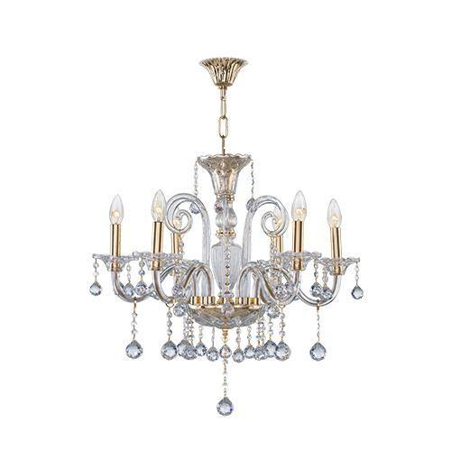

**Classic Chandelier 6 Bulbs**

3 sold in last 20 hours

Classic Chandelier 6 Bulbs About This Product Brand : AsfourProduct Type : ChandelierProduct Family : CrystalColor :...

Vendor: [Asfour Crystal](https://shop.asfourcrystal.com/collections/vendors?q=Asfour%20Crystal)

SKU: 31411/128/119/124

Availability: In Stock

Product Type: Chandeliers

Brand :: Asfour

Top of Form

Bottom of Form

Top of Form

Subtotal: EGP 11,203.00

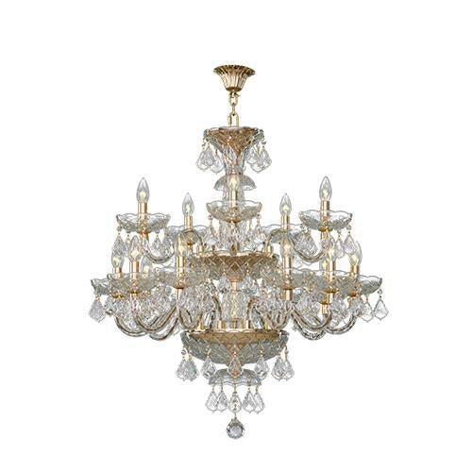

**Crystal Chandelier Asfour 15 Bulbs**

7 sold in last 18 hours

Crystal Chandelier Asfour 15 Bulbs About This Product Brand : AsfourProduct Type : ChandelierProduct Family : CrystalColor...

Vendor: [Asfour Crystal](https://shop.asfourcrystal.com/collections/vendors?q=Asfour%20Crystal)

SKU: 31411/108/119/105

Availability: In Stock

Product Type: Chandeliers

Brand :: Asfour

Subtotal: EGP 22,392.00

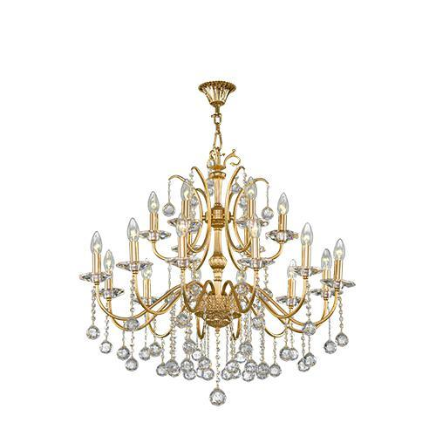

**Crystal Chandelier 18 Bulbs Gold**

Crystal Chandelier 18 Bulbs Gold About This Product Brand : AsfourProduct Type : ChandelierProduct Family : MajesticColor...

Vendor: [Asfour Crystal](https://shop.asfourcrystal.com/collections/vendors?q=Asfour%20Crystal)

SKU: 32111/114/119/117

Availability: In Stock

Product Type: Chandeliers

Brand :: Asfour

Subtotal: EGP 25,862.00

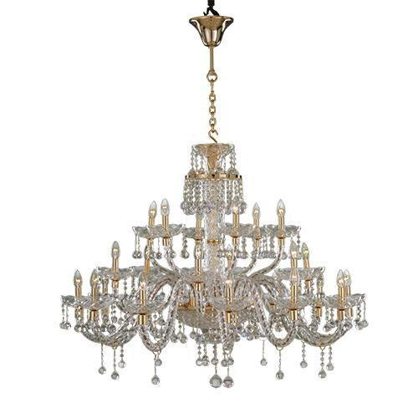

**Asfour - Crystal - 24 Bulbs - Gold - Ball Clear**

Asfour - Crystal - 24 Bulbs - Gold - Ball Clear About This Product Brand : AsfourProduct...

Vendor: [Asfour Crystal](https://shop.asfourcrystal.com/collections/vendors?q=Asfour%20Crystal)

SKU: 31411/125/119/124

Availability: In Stock

Product Type: Chandeliers

Brand :: Asfour

Subtotal: EGP 31,995.00

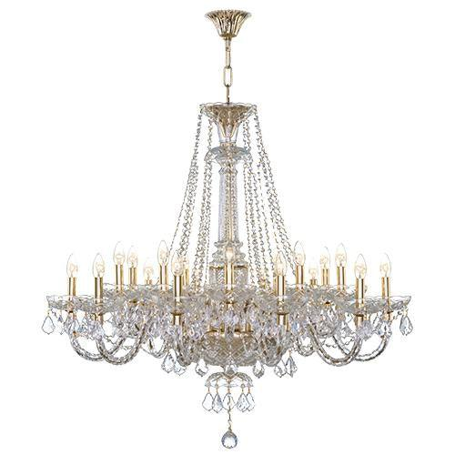

**Crystal Chandelier Asfour 20 Bulbs**

Crystal Chandelier Asfour 20 Bulbs About This Product Brand : AsfourProduct Type : ChandelierProduct Family : CrystalColor...

Vendor: [Asfour Crystal](https://shop.asfourcrystal.com/collections/vendors?q=Asfour%20Crystal)

SKU: 31411/116/119/105

Availability: In Stock

Product Type: Chandeliers

Brand :: Asfour

Subtotal: EGP 28,796.00

# Asfour Crystal - Empire Chandelier - 19 Bulbs - Gold - Ball Clear Crystal Chandelier Asfour 19 Bulbs

Crystal Chandelier Asfour 19 Bulbs About This Product Brand : AsfourProduct Type : ChandelierProduct Family : EmpireColor...

Vendor: [Asfour Crystal](https://shop.asfourcrystal.com/collections/vendors?q=Asfour%20Crystal)

SKU: 31511/131/119/131

Availability: In Stock

Product Type: Chandeliers

Subtotal: EGP 46,199.00

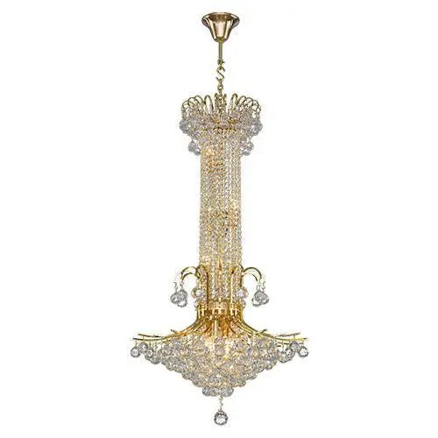

**Chandelier Asfour 15 Bulbs Gold**

Chandelier Asfour 15 Bulbs Gold About This Product Brand : AsfourProduct Type : ChandelierProduct Family : EmpireColor...

Vendor: [Asfour Crystal](https://shop.asfourcrystal.com/collections/vendors?q=Asfour%20Crystal)

SKU: 31511/453/119/124

Availability: In Stock

Product Type: Chandeliers

Subtotal: EGP 31,413.00

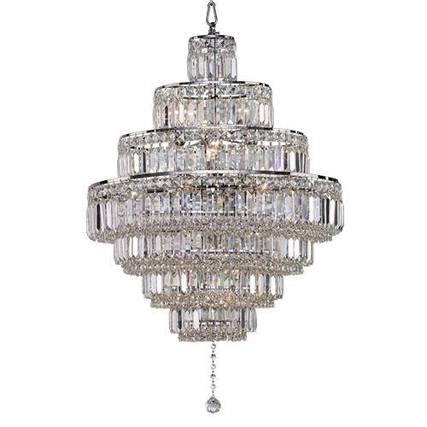

**Chandelier Brand Asfour 18 Bulbs**

Chandelier Brand Asfour 18 Bulbs About This Product Brand : AsfourProduct Type : ChandelierProduct Family : EmpireColor...

Vendor: [Asfour Crystal](https://shop.asfourcrystal.com/collections/vendors?q=Asfour%20Crystal)

SKU: 31511/132/121/131

Availability: In Stock

Product Type: Chandeliers

Brand :: Asfour

Top of Form

Bottom of Form

Top of Form

Subtotal: EGP 27,710.00

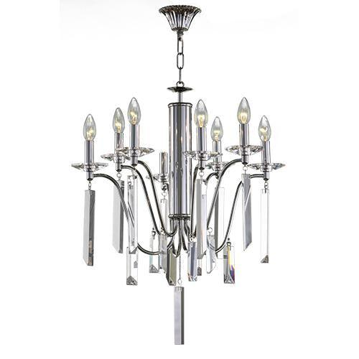

**Crystal Chandelier Asfour 8 Bulbs**

Crystal Chandelier Asfour 8 Bulbs About This Product Brand : AsfourProduct Type : ChandelierProduct Family : MajesticColor...

Vendor: [Asfour Crystal](https://shop.asfourcrystal.com/collections/vendors?q=Asfour%20Crystal)

SKU: 32111/143/121/133

Availability: In Stock

Product Type: Chandeliers

Brand :: Asfour

Top of Form

Bottom of Form

Top of Form

Subtotal: EGP 16,626.00

# https://shop.asfourcrystal.com/cdn/shop/files/Modern-Chandelier-Tiara-5-Bulbs-TIARA-1688387455316.jpg?v=1688387456 Modern Chandelier Tiara 5 Bulbs

Modern Chandelier Tiara 5 Bulbs About This Product Brand : TiaraProduct Type : ChandelierProduct Family : TiaraColor...

Vendor: [Tiara](https://shop.asfourcrystal.com/collections/vendors?q=Tiara)

SKU: 71111/162/121/107

Availability: In Stock

Product Type: Chandeliers

Brand :: TIARA

Top of Form

Bottom of Form

Top of Form

Subtotal: EGP 5,550.00

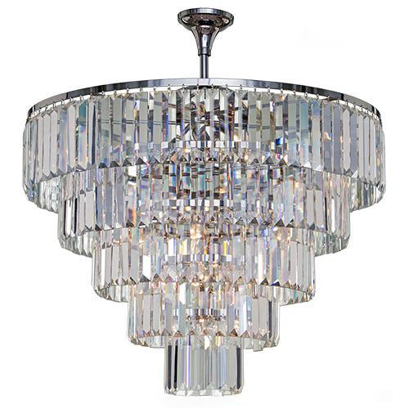

**Classic Chandelier Asfour 18 Bulbs**

Classic Chandelier Asfour 18 Bulbs About This Product Brand : AsfourProduct Type : ChandelierProduct Family : EmpireColor...

Vendor: [Asfour Crystal](https://shop.asfourcrystal.com/collections/vendors?q=Asfour%20Crystal)

SKU: 31511/532/121/131

Availability: In Stock

Product Type: Chandeliers

Brand :: Asfour Asfour

Top of Form

Bottom of Form

Top of Form

Subtotal: EGP 66,526.00

Bottom of Form

Bottom of Form

Bottom of Form

Bottom of Form